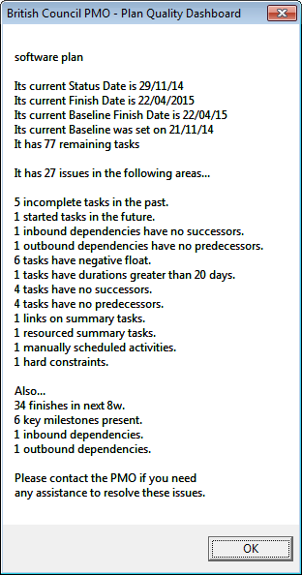

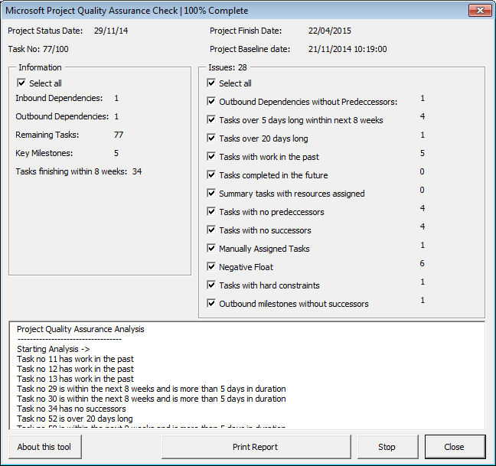

|  |  |  |  |
| --- | --- | --- | --- |
| Test | Old | New | Comments |
| In past | 5 | 5 |  |
| In future | 1 | 0 | New does not count if = 100%. Does count <100% |
| In dep no succ | 1 | 1 | Title wrong on screen, says "outbound milestone" |
| Out dep no pred | 1 | 1 |  |
| neg float | 6 | 6 |  |
| Over 5 in 8 | 0 | 4 | Old no longer counts. Not applicable to British Council |
| Over 20 | 1 | 1 |  |
| No succs | 4 | 4 |  |
| No preds | 4 | 4 |  |
| Summ links | 1 | 0 | New does not count errors on summaries |
| Summ res | 1 | 0 | New does not count errors on summaries |
| Manual | 1 | 1 |  |
| Hard con | 1 | 1 | Constraint is on a task. New does not count constraints on summaries |
|  | 27 | 28 |  |